**LiveMusic Page Design**

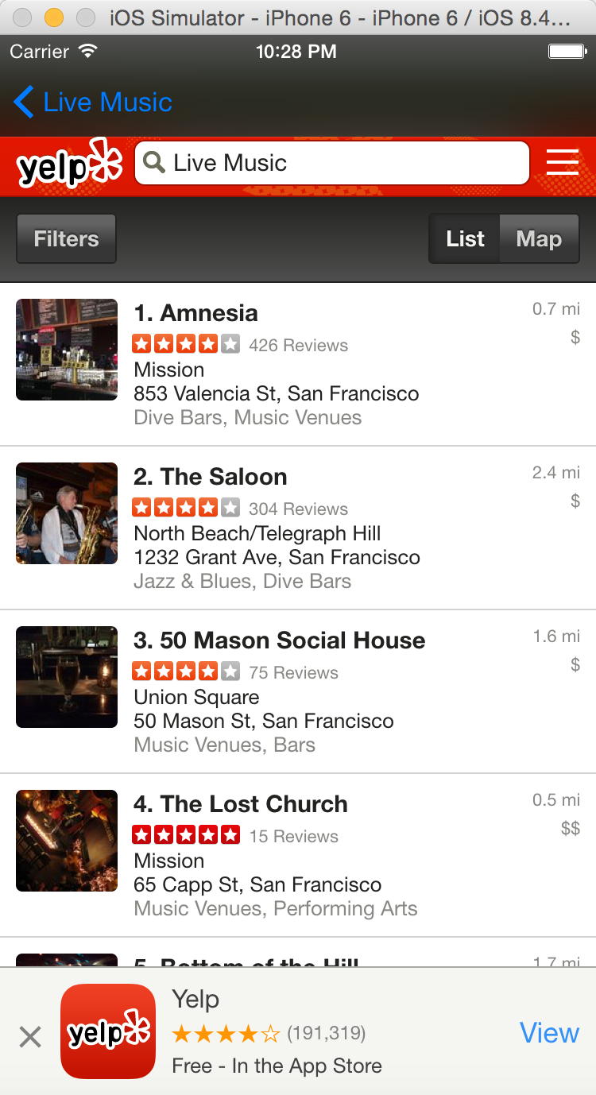**Elements:**

Navigation Buttom: “Live Music”, blue; back to last page(Live Music search list)

View Backgroud: black

Webview:

With filter “Live Music”

